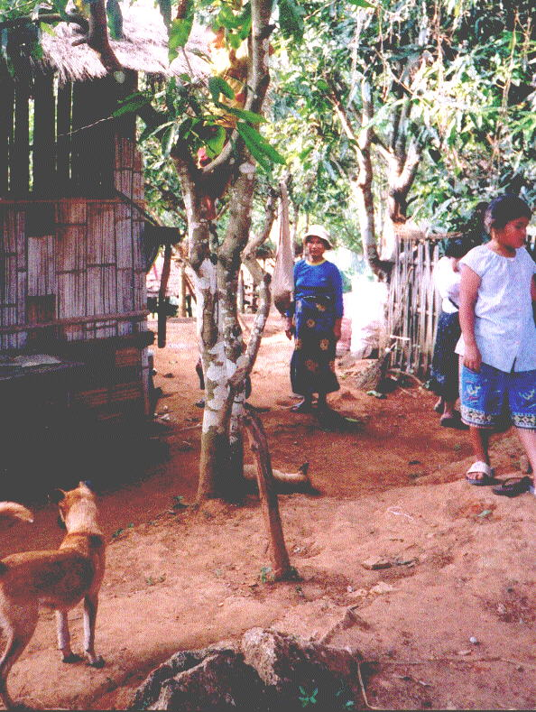

A Mai Gone "Expedition"

We had already confirmed with Rev Abel that it was not necessary for us to carry our own bedding, but it was still with some trepidation that we headed off to catch the 6.30 pm bus from my home in Nakhonpathom for the 400 mile journey to Chiang Mai. The trepidation was the result of Dr. Huang's description of the journey from Chiang Mai to Mai Gone, including the 2 hour walk from the road UP to the village! The bus company were unable to give us an accurate arrival time, as it might have been necessary to divert via Bangkok to pick up more passengers - it might be 3 am or 5 am. Rev Abel arranged to collect us at 5 am having first dropped his wife Ruth off at the market (not unusual in Thailand). As it was, we arrived at 3.15 am but the time passed quickly, helped by a nearby 7-11 which was open 00-00.
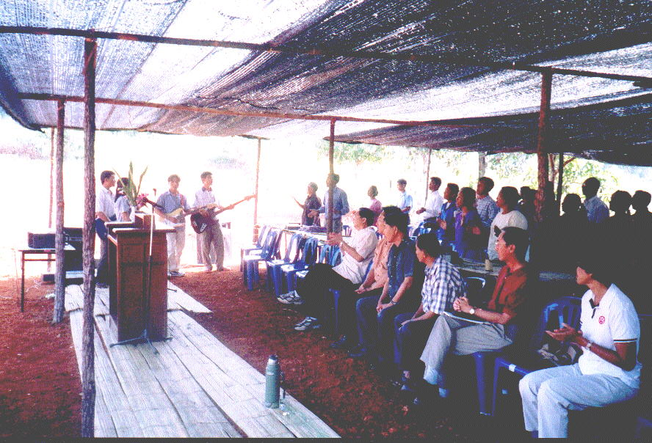

Abel arrived bang on time and he drove us around to his new home with suggestions that we showered, had a sleep and a light breakfast. In the meantime, he went off to help his wife and, on his return, we set off to meet the Singaporean party of 4 who were coming on a direct flight, arriving 10.30. At the airport we were met by Ruth and their two sons Mark, 16 yrs, and Luke 10 yrs, and were eventually joined by Pastor Anthony, his wife Cecelia, an Elder Kam Seng and a young member of the church, Lydia. We then went off to have a meal in a nearby restaurant, which they had obviously used before, where you paid before you ate and then ate as much as you like – useful as Wantana and I did not know what to expect over the next few days.
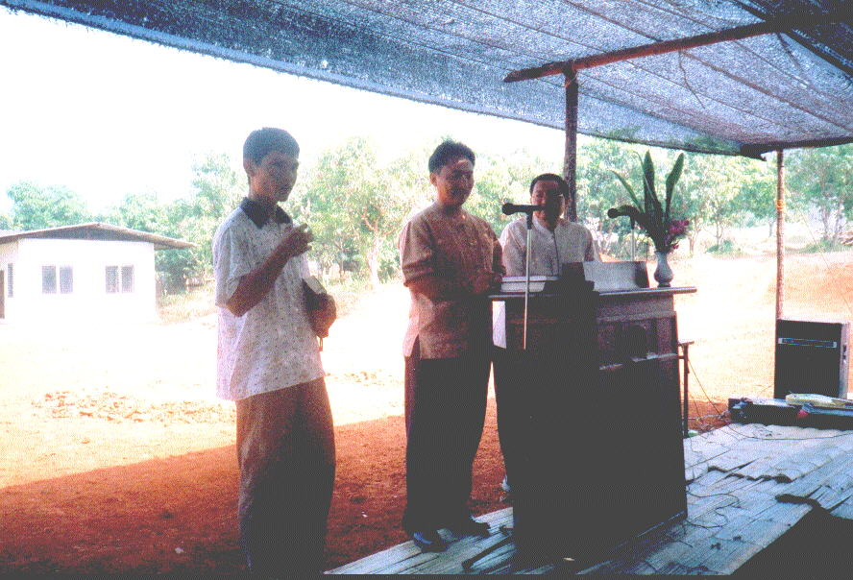

It was then off to Mai Gone and after some two hours on the main highway to Fang, we turned left onto the approx 5 km road to the village. Apart from two small stretches, the whole length of it was concrete until we reached the lower larger part of the village where we turned right onto a very steep, rutted dirt track. Fortunately, both vehicles were 4 wheel drive, it is now the dry season and it was no more than ¾ Km.

We passed many of the Lahu houses that were of the usual construction. Built high on stilts, the main building material was split bamboo, floor and all. The roofs were thatched and in many of them, the cooking fire was on the floor and I was told that the smoke from the fire helps to waterproof the thatch. Ventilation was no problem as the walls had plenty of gaps. Rain was prevented from coming through the walls by a large overhang on the foot. The poverty was obvious but everything inside was spotlessly clean.

The biggest surprise was the guest house and the church, both large buildings of concrete construction so obviously there will be no problems getting materials up for the orphanage, the site for which is opposite the church. The area had already been cleared and a temporary shelter had been built for the dedication ceremony, which would include a feast for which a pig had been slaughtered the day before.
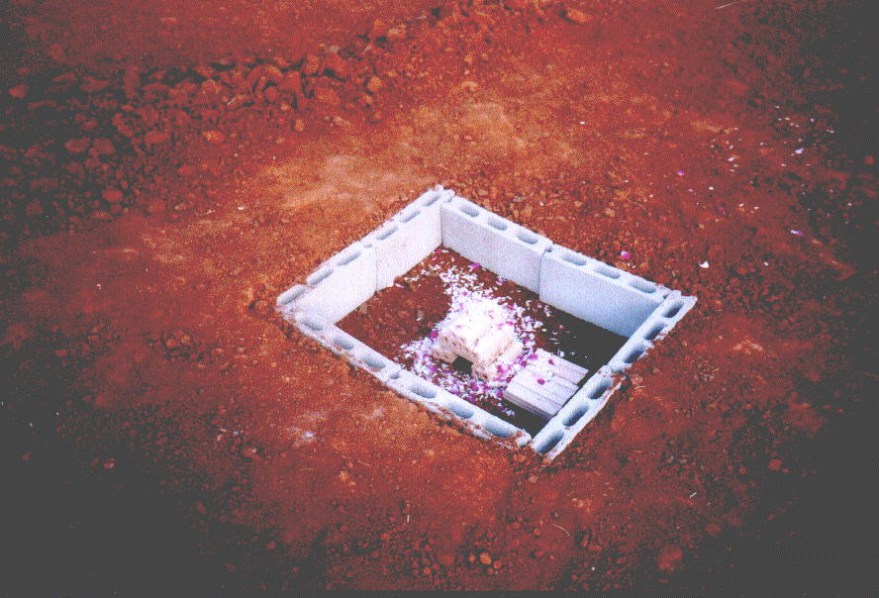

The guest house had a large central area, to the rear of which was a kitchen. There were 3 other rooms, one on the left and two on the right, all of which had bathrooms including showers (cold). The village had large storage tanks on the hillside with a very good running water system from a stream several Km away, all provided by an American organisation called "Heifer". We took our meals in the central area, sitting on the floor Thai style and I cannot praise the food we ate highly enough – the cook for most meals was Rev. Abel!
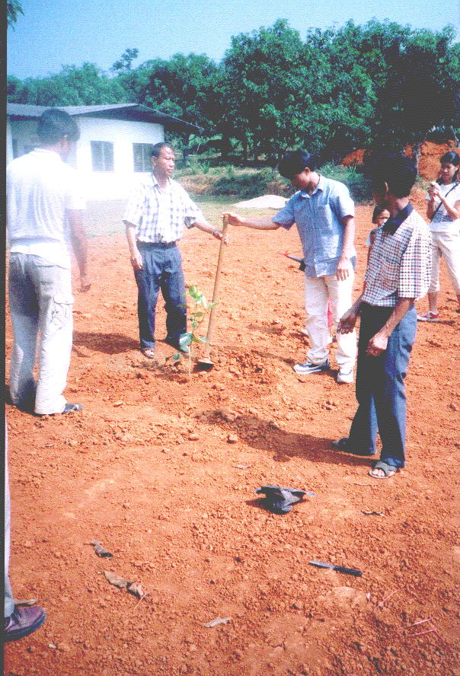

The Singaporeans were well known to the villagers and Wantana and I were made to feel like part of the family. Cecilia and Lydia were wonderful with the children and the porch in the front of the house became the Youth Club for the 5 days I was there.

Each morning started with devotions and on Saturday we congregated for a short meeting at 7 am with breakfast at 8, then preparing for the ceremony at 10 am. When we finally gathered there must have been close to 100 people present, including some from the Thai community in the lower village, neighbouring hill tribe villages, the village headmen from both the Thai and Lahu community and the Thai government representative. I was personally impressed with the musical talents of the Lahu, their harmonies reminded me very much of the Maori of New Zealand. The singing was led by three sons of the village evangelist, self-taught guitarists and very talented (the fourth son attends Bible College in Chiang Mai and acted as interpreter for the Thai speakers attending the service – he also speaks passable English – a very talented family).
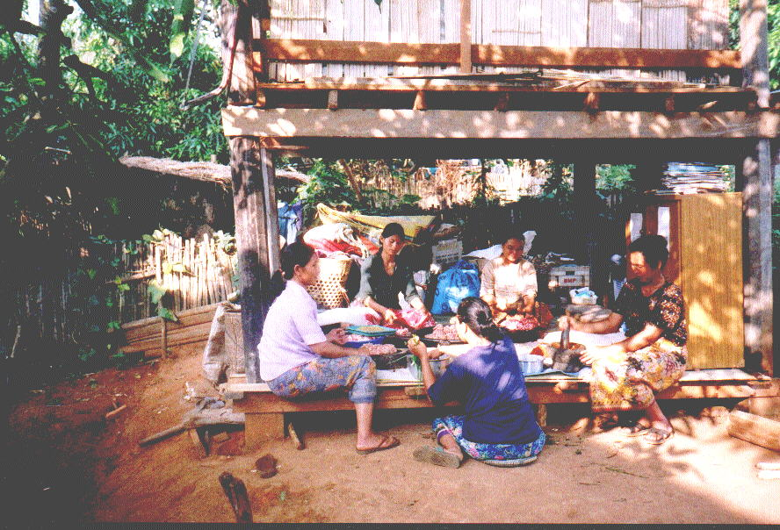

The service proceeded with hymns, prayers and an address by Pastor Anthony, given in English, translated into Lahu by Rev Abel and Thai by Supot. The next part of the ceremony, referred to as the Ground Breaking, took place at a previously prepared hole in which bricks had been placed. This was blessed by Anthony and Abel and orchid flowers were scattered over it. Three fruit trees were then planted, one each by the two headmen and one by the government representative.

We then sat down to a sumptuous banquet, eaten off banana leaf plates, which consisted of rice and five dishes, all novel to me (Lahu cuisine) followed by a sweet prepared by Abel's mother and served in enormous portions (Wantana and I shared one and I couldn't even manage half!). The remainder of the day was spent visiting houses in the village.
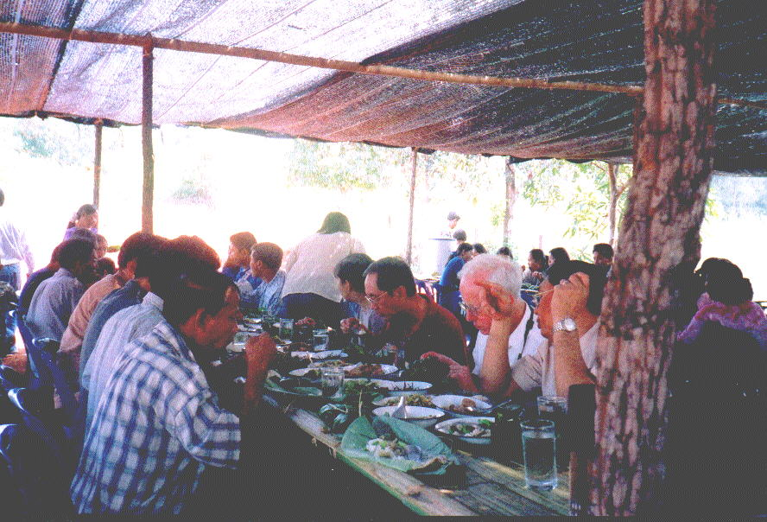
Wantana returned to Chiang Mai on Sunday, with Ruth who was preparing the boys for school on Monday, and then to Nakhonpathom that night to get back to her sick mother. I stayed on and visited a number of other Lahu Christian communities but that will have to wait for another newsletter if you wish it. I would like to share Sunday morning with you.
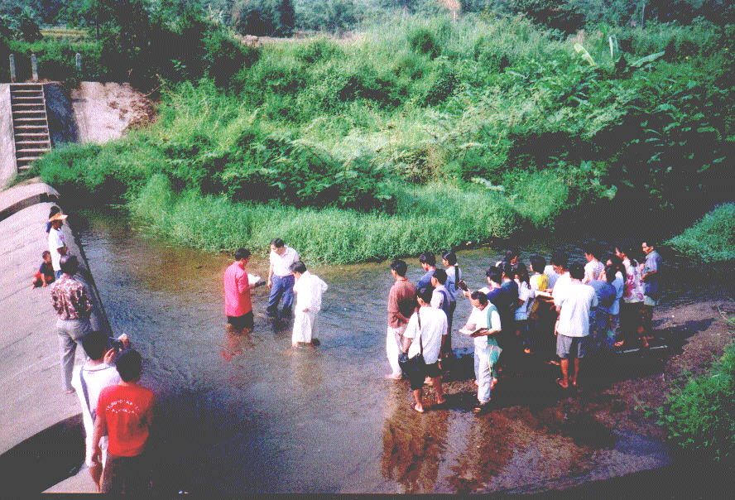
I knew that there was a service at 10 am, but I later learned that there were 3 adult baptisms before that and that they were by full immersion in a nearby stream. It was a picture straight out of the New Testament and John the Baptist – I hope my pictures do justice to it.

My lasting memory of the visit is the friendliness, the generosity and the faith of those people. I do commit to you the need for this orphanage, having met the leaders of these communities and heard their tales of fathers shot when catching fish in a river just over the border, or abusing drugs or, as in one village, dying from alcohol poisoning from illegal stills. A Christian family had adopted one boy in Mai Gone after his mother had sold him for 200 Baht, about £3.

I hope that I can get back soon to Mai Gone – perhaps when there is some painting to do, but at the moment I am seriously thinking of staying on for the dedication ceremony the last weekend in March. Anybody care to join me?

Best wishes from Thailand, Bill Davies

Mae Gone Orphanage
Elder Cho Kam Seng

We made our way up the mountain village Mae Gone like in previous mission trips. Rev Abel driving a 4 wheel-drive carrying the team and his wife Ruth following behind in another, loaded with fresh food from Chiang Mai market. As we wound up the dusty, bumpy road, the breeze gradually became cooler. The pastoral scene spreading out below was balm to my weary body and spirit.

I looked forward to a week of renewal, having had a very hectic and physically exhausting year. I had a bag full of books with me. It would be wonderful to sit at the veranda of the Mission House, enjoy the cool mountain air with a warm drink and a good book. Occasionally, to add to the pleasure, I could look straight ahead over the mountains, down south towards Singapore and imagine my colleagues slogging hard at the construction sites. I had promised to pray for them everyday. I also looked forward to the smell of the farm, the crowing of roosters, the greenery, and the grove of mango trees, which were already bearing fruits.

But, as we turned into Mae Gone, we saw the mango trees were gone. Bulldozer cleared the ground. Now bare and brown just like the construction sites I traveled so many miles to get away from. A few Lahu men were busy erecting the bamboo shed and tables for the ground-breaking ceremony. We greeted each other warmly. Mae Gone Christians are gentle, kind and hospitable. An excellent people to help nurture children. They are much blessed by the Lord, as evident by the increased number of pigs and buffaloes.

The next morning, 10 am. 25th Oct 03, a crowd of about 80 people gathered under the shed. Greetings, messages, prayers; then Rev Anthony and Rev Abel laid a few bricks and cast some flowers over them. The village headman, a Thai, welcomed the Lahu resident’s initiative. He was pleased that the orphans would be given a chance to survive. Two other Thais represented the Authorities. They planted a fruit tree each. Before they left, they granted approval to proceed with building. Praise God.

The orphanage will be two-storey, 27mx15m. Ground floor contains the hall for meals and study, kitchen, office and room for housemaster. Three rooms for boys and three for girls will be on the first floor. Rev Abel had bought two paddy fields to cultivate crops for sustenance. He intends to rear fishes, pigs and buffaloes. Vegetables and fruit trees will also be planted in the orphanage compound. Residents will learn agricultural skills and help in farming. For the children’s education, they can attend the government school in the village. Rev Abel is praying for two godly families; one to look after the children and another the farm. Various families are caring for already 10 orphans now. Eventually, the orphanage can look after 50.
Poverty among the hill tribes made them easy targets for vices. Many died young from drug addiction or HIV infection, leaving behind small children. If they are fortunate, grandparents will raise them. If not, they are left to the mercy of unscrupulous people. Often they are sold cheap. Among the Mae Gone children, there is an orphan bought with only Baht 200 by a couple addicted to drugs. He is 11 now, intelligent, a natural leader. I watched him play UNO or ‘Old Maid’. The way he held the cards, the sly look, eyes darting at opponents, was impressive. I could well imagine him, 10 years hence, playing cards in some smoke-filled bar, a professional gambler. But given the chance, by God’s grace, he can be different. As he played, he subconsciously broke into songs in his husky voice. Singing beautiful, melodious Lahu and Thai songs. And I recalled Rev Abel said good singing is prerequisite of Lahu pastor.

One evening we returned from visiting a church in another village to find the dog growling at a pathetic kitten. It was battered, dirty, and barely bigger than a man’s hand. Someone shoo away the dog. Someone said ‘Don’t touch the kitten. It is diseased and may bite’. We watched it limped into the dark. Later, while watching the children play on the veranda, I noticed 4 year- old Timothy coming up the steps. The little kitten was meowing loudly in the crook of his left arm. He kept pressing it to his chin, tenderly like a mother comforting her crying baby. He set down and joined in the game UNO. Eyes on the cards but still comforting the kitten. Before long it quiet downs and slept. He didn’t know I was watching. I learned a lesson of tender mercy.

Nice buildings can be built. The best facilities can be provided. But what really matter are people with tender heart like Timothy; who love God and want to share His love with the needy children. Rev Abel shared that he had prayed a long time, took steps to make long term provision before committing to start this orphanage. It is not to be taken lightly. Children’s lives are at stake. Let’s pray for godly people, committed to the work of loving and nurturing them. Let’s also do what we can to help as the Lord leads.



Mission Trip Diary
24th Oct Friday - Arrived at Mae Gone late afternoon. MG brethrens busy preparing for ground-breaking service. Erecting bamboo shed. Preparing feast for 100 guests. Notice increased number of pigs and buffaloes. Fellowship with Ule’s family and Rev Abel.

25th Oct Saturday - Service at 10am. 80 attended. Rev Anthony shared about need to care for orphans as God commanded. Ground- broke and trees planted to launch Orphanage. Great Lunch. Ruth and mother returned to Chiang Mai. Going to miss their wonderful cooking.

26th Oct Sunday - Morning Devotion sharing by Mr. Bill Davies. Ps 127:1-3 and Ps 126:3. Except the Lord built, we labor in vain. Worship Service message by Eld Cho. Deut 7:6-21. The Lord thy God has chosen you. Worship at Nawng Khio in afternoon. Rev Anthony preached ‘Who is Jesus.’ Great feast of peanuts, sweet potatoes and bananas. Dinner cooked by Rev Abel. Surprise. Great cook also!

27th Oct Monday
Visited Pang Kwai village, Pastor Ja-Shu’s extended family. Cecilia and Lydia had children program. Heifer Project also established here, providing water system and loan of life stock for start up. Nice flowering plants around the church. Pretty.

28th Oct Tuesday
Up to the highest mountain village, Pa Bo Klang. Panoramic view, good place for church camp. Small church. Visited all 5 families.

29th Oct Wednesday
Jiang Jan village. Pastor Ehneh slaughtered a pig to feed us. Wonderful Lahu dishes. Time of sharing and prayer. Up to Huey Tad village to visit Rev Abel’s parents. Long established Christian village.

30th /31st Oct - Chiang Mai and home.

