THAILAND GOSPEL TELEGRAM

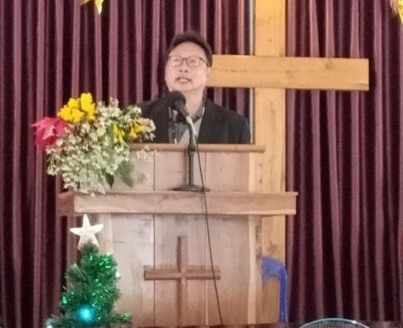
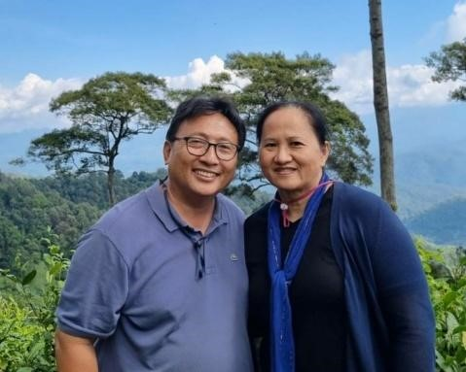
March

20
22

Missionaries:

Abel & Ruth Sairattanyu

/4 Soi 2 Tung Hotel Rd.
21

Chiang Mai 50000 Thailand

Phone:
+66 8195 01437

Email
:
sairatt@hotmail.com

Forwarding Agent:

Tom and Linda Nation

1007

Egyptian Trail.

Tuscola, IL 61953

Phone:

217
-
4933971

Email: tom.nation@netcare
-
il.com

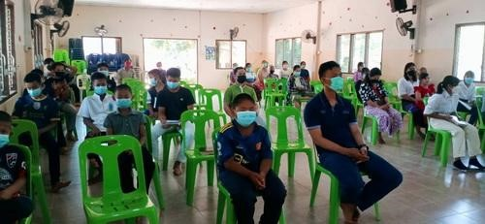
At the moment there is an increase of Covid 19 cases in the villages that we minister in. We ask that you please pray for our brothers and sisters in Christ in those villages that God will have mercy on them and keep them safe as well strengthen them through these difficult times as said in Psalms 91:1-3 Whoever dwells in the shelter of the Most High will rest in the shadow of the Almighty. I will say of the Lord, “He is my refuge and my fortress, my God, in whom I trust.” Surely he will save you from the fowler’s snare and from the deadly pestilence.

Mae gone church worshipping on site
Currently, there are only some churches that have been able to worship on site. Those villages with a large number of infections are still not able to worship on site. Our mission has done the best we could to help and encourage our brothers and sisters in Christ at those villages that have been heavily affected by the spread of covid. Due to the large number of infections in those villages the village authorities locked down those villages restricting travel in or out of those villages resulting in people not being able to go out to buy food or neccesary items. Our mission got our associated churches together to donate and send food items and neccesities to both Christians and non christians of the affected villages. We saw this as a good opportunity to spread the Gospel through this humanitarian work and the results have been very positive. Some of the villages that have been against Christianity have now opened up and and given us the opportunity to share the Good news.
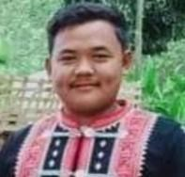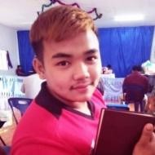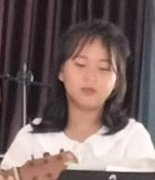

Chai pond A nu pong Ni da Yong yut
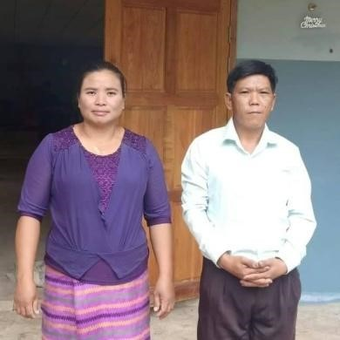
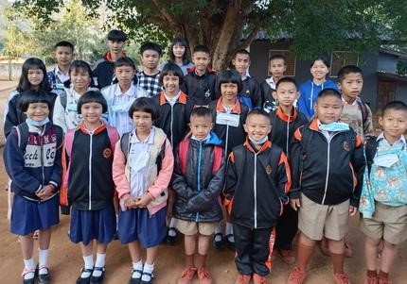
We thank God that at Pa sak Church we have 4 people who have decided to accept Christ into their lives and are ready to be baptized as soon as the covid 19 situation at Pa sak village gets a little better. At this village we do not yet have a parsonage for the minister. We plan to build a parsonage at this village with a total cost of $2,565. We have already raised $1,000. Please pray for this project that we may be able to raise enough funds to build this parsonage. Minister and family The orphanage children (some of the kids are not in the picture) Nut Cha

We have 25 children at the orphanage this year. We also have one of the girls who will be finishing high school. Her name is Nut cha. Nut cha will be coming to the city of Chiang Mai to continue her studies in university. Please keep her and her studies in your prayers. Please pray also that we will have to necessary funds for her to continue her studies. 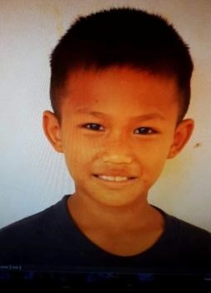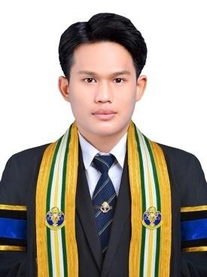

Pi ya (when he first came) Pi ya (now)

In addition we also thank God for Pi ya who is now a young man and is one of our kids from the orphanage. This year Pi ya has graduated from University. He studied at a Physical Education University. Before working Pi ya will be doing his part for the country and will be doing his national service. This is still a law in Thailand that every male at the age of 18 will have to serve in the military. This service will take around 6 months since he will be signing up instead of being drafted which would take about 2 years. Please keep him in your prayers that God will watch over him as he completes his national service.

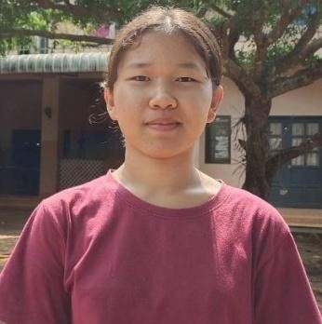
As for Ruth and I, we feel very blessed to be here and serving God even though at the moment there are certain complications due to covid 19, since we are not able to move around freely to visit and preach at the villages as before. As for Ruth and I, we feel very blessed to be here and serving God even though at the moment there are certain complications due to covid 19, since we are not able to move around freely to visit and preach at the villages as before. Despite this we thank God for technology that makes it possible for us to still be able to talk and encourage the villagers during these difficult times. Nonetheless, we have been thankful to God for his mercy and grace in keeping our family safe from the pandemic. We also thank you for praying for Ruth, at the moment she is doing well and she has another appointment with the doctor in July to see if she will need to have the surgery. Once again, We thank you so much for your prayers and for your support, and thank you always for your faithful partnership in the Good work that we are doing for our Lord and saviour here in Thailand.

