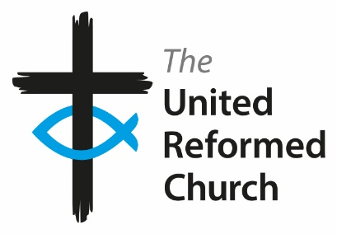
Cheadle Hulme United Reformed Church

ENVIROMENTAL POLICY ~ Plans for Eco-Church

God charges us to be custodians of His planet, all the plants, animals and all communities, so we must plan what our normal responses should be in a range of situations. Early human kind were provided with food by fishing and hunting but we have been too successful – there are now 7 billion people on the planet so we must rein in our expectations. This is little room for selfishness, individually or internationally.

Furthermore, we realise that climate is changing, whatever the cause, so we need actions in place to mitigate the consequences which we are already seeing. There is a disproportionate greater impact in countries without resources and in marginalised communities around the world.

The Elders of this church intend…
- Actions, using the 6 R's: REDUCE, REUSE, REPAIR, RECYCLE, RE-THINK and REFUSE.
- Promotions of environmental actions and policies, in meetings, publications and worship.
- Prayer, for our planet, God’s patience and for support of our efforts.
- Continued financial efforts to help charities at home & overseas if impacted badly by climate.

We will endeavour to…
…reflect environmental concerns in our worship and prayer (eg the Green prayer).
…use the local authority waste management scheme separating our waste, inc electrical.
…reduce our carbon footprint regarding use of fuel, power, and food /water.
…manage our small plot of land and gardens as sustainably as possible.
…not invest in artefacts or financial schemes that are not environmentally friendly.
…invest in projects and initiatives that are environmentally friendly.
…continue to sell Fairtrade products and support Tradecraft Exchange.
…encourage suitable lifestyles, promoting exercise and responsible nutrition.
…seek to manage our buildings and our grounds to the gain of the environment.
…seek best practice in activities affecting the environment and bio-diversity.
…endeavour to set and achieve goals, eg Bronze/Silver awards ~ Eco-church movement.
…engage our community in aspects of this policy, including our hirers and pre-school group.
…encourage others both in and without our membership to do likewise.
…re-consider this policy appropriately and regularly.
BSV 23/11/2022
TBC
Energy audit (needs fuel figures from accounts of last few yrs.)
Review cleaning materials
Building Insulation
Solar panels
Bird boxes / Insect hotels, compost heap (involve pre-school?)
Use less paper – toilet~, printing~, use more IT (computer/projector, email etc etc)
Recycle books, paper etc
Encourage sustainable diets
Environmental events inc community events

